**Assignment no. 6**

**Cover Letter:**

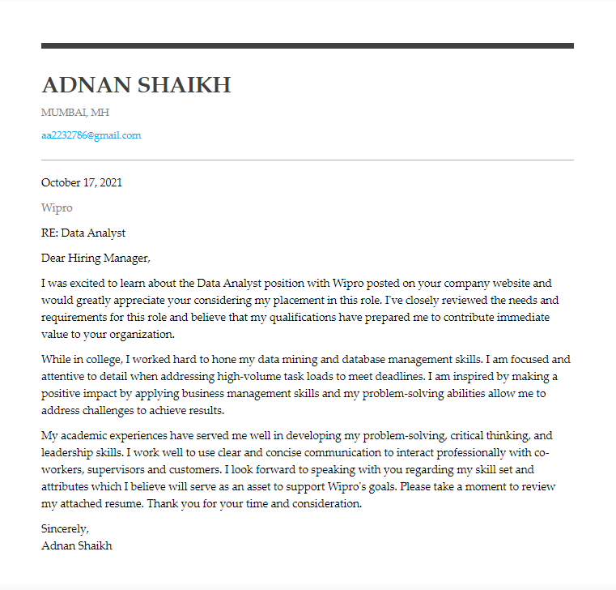

**Resume:**

